MEET MRS. UNDERWOOD
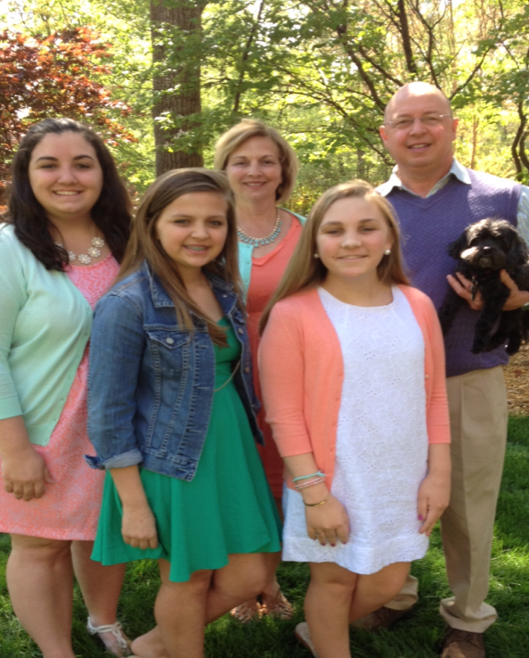
My name is Wanda Underwood. This is my eighth year teaching at Olde Providence. I have been teaching for 20 years. My husband, Phil, and I live in Matthews. We have four children. Our son, Will, is the oldest. He is a manager at Firebirds at South Park. He is getting married to Ms. Cantor in May. Our oldest daughter, Karen, is in her last year of graduate school. She is studying to be a Speech Pathologist and she is getting married in August. Our daughter, Anna, is a sophomore at Providence High School and our youngest daughter, Faith, is a freshman. I enjoy spending time with my family, reading, walking, and going to the beach. I love children and serve at my church taking care of babies.

