MEET MRS. DYER

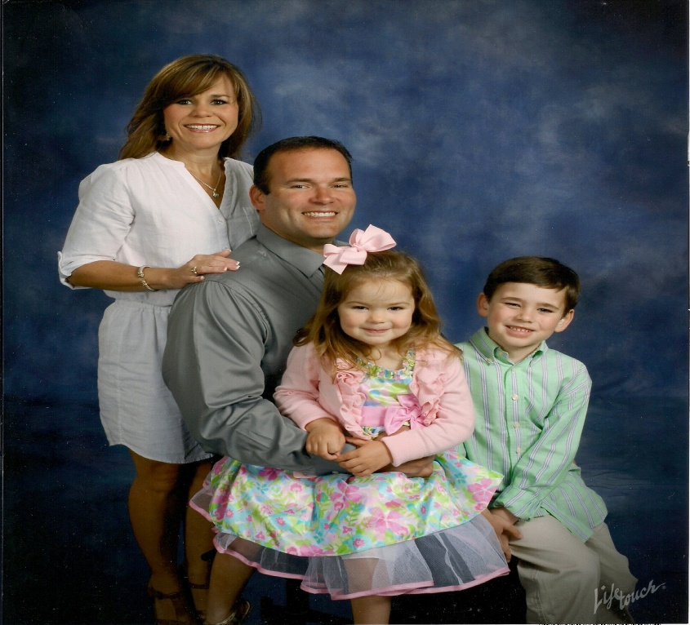

Hello! My Name is Melissa Dyer. This is my third year teaching Kindergarten at Olde Providence and my eighteenth year teaching. My husband and I married twelve years ago and moved to Union County. We have two children and a dog. My children attend Olde Providence Elementary. My son is in 3rd grade and my daughter is in Kindergarten. Outside of school, I enjoy spending time with my family, going to beach, cooking, shopping, and exercising.

