MEET MRS. ALLEN
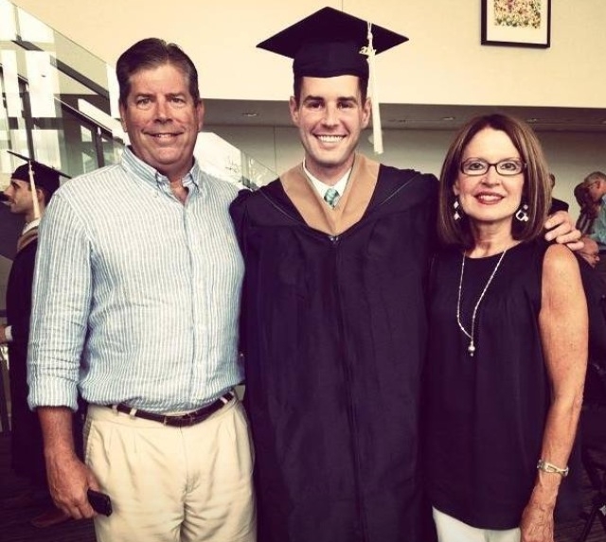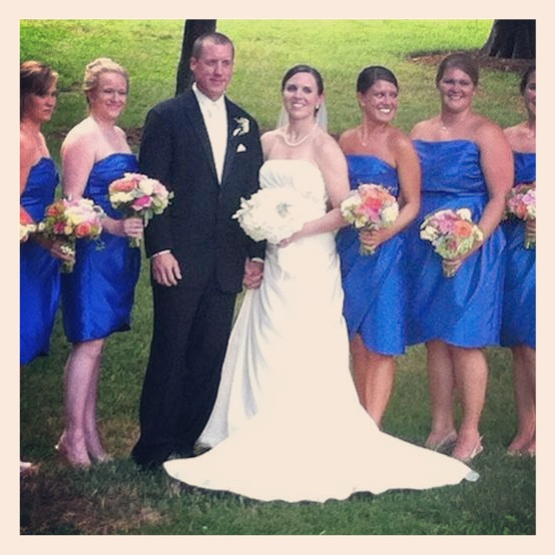
Hello, my name is Lynn Allen. I am a native of Charlotte and have worked at OP for 21 years. My roles at OP include parent, assistant and teacher. I taught 2nd grade for 19 years. Olde Providence is very special to me and has been a big part of my life! I am married and have two grown children. My daughter Meredith is a nurse at Hemby Children’s Hospital and travels with us on most field trips. She is married to Matt who teaches at Myers Park High School. Chad, my son attended OP from 2nd-5th grade and he is now 26 years old!! He works at Regions Bank in Charlotte as an Investment analyst. I love being a part of OP!

