MEET MISS HAYES
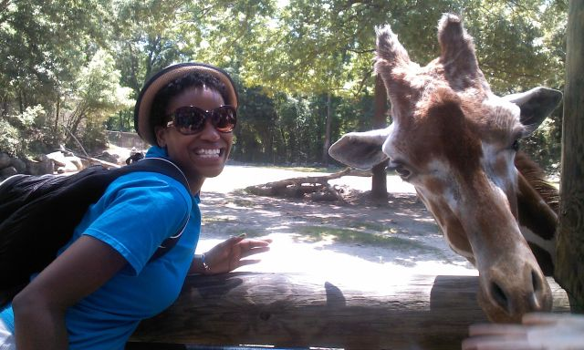
Hello. My name is Erinn Hayes. I am a lover of education. I’ve been teaching elementary school for 7 years. This is my 4th year here at Olde Providence. I taught 2nd grade for three years at Billingsville Elementary School. I am also coaching basketball at Myers Park High School. I love to read, sing, dance, and play basketball. Life it what you make it, so I truly believe in making my life one that is filled with positive energy so that I can share it with the world!

